CS 320 Project Two: Summary and Reflections Report
Gaelyn Jackson

I incorporated the software requirements in my overall project, by first organizing each requirement to each milestone. For each milestone, I organized what information each milestone needed, such as milestone one’s contactservice requirements having the contact Id, first name, last name, phone number, and address. I then ensured that I made note of each requirement, such as contact Id not being able to be null over longer than 10 characters. I did this for each milestone, with me reviewing the requirements multiple times to ensure that I met all the requirements. Once I finished this and ensured that I met all of my requirements, I then was able to create JUnits tests for each attribute to ensure that my code met the requirements of not being able to accept the conditions for each one.
When it came to testing my project one assignment, I first used the same code that I used for all three of my previous milestones. I tested each of these milestone codes using JUnit testing and ensured that each test passed. For example, in the second milestone, I used a JUnit test to ensure that the taskId for the application would not accept an id that was over 10 characters. Once I checked that each individual component was still passing their tests, I incorporated all these files into one project, Project One, and then ran another JUnit test to check that all tests included passed. I felt confident in my JUnit testing once I noticed that all of my testing passed through multiple different tries, showing me that I completely added all the requirements to make these tests pass.
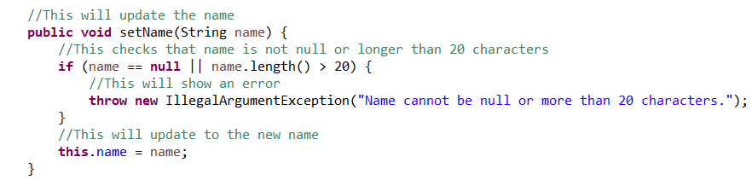
In order to ensure that all my JUnit tests passed, I had to also make sure that my code was technically sound, including comments that explained what I intended the code to do. For example, in this line of code, I explain that the intended function is to update the name and to check that the name is not null or longer than 20 characters, or else it would throw an error:

This also acts as a way for me to go back through my code if there is an error, so I can determine that the code is doing as it is supposed to, and I can reference if my logic is correct, so I can change it if needed.
I furthermore made my code efficient by including the relevant libraries, so that I wouldn’t use more memory and search through the code quicker to find information, rather than looking through an entire stored list. For example, in my contactservice and taskservice files, I used import java.util.HashMap, which uses HashMap to store data in key-value pairs and looks up data quicker. In these same files I used import java.util.Map I am able to use Map to call the HaspMaps stored key-value pairs.:
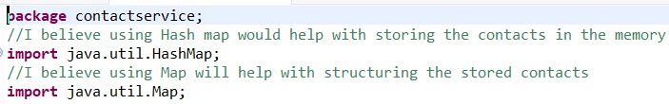
I utilized several testing techniques as I worked on my milestones and in Project One. First, as I’ve stated before, I gathered the requirements for each milestone and ensured that I had all of them gathered and correctly understood each requirement. Then after I gathered requirements, I looked through my written code before testing it just to find any errors in the logic. Then after I completed my testing classes, I finally ran them through JUnit testing, ensuring that all the tests I included throughout each milestone passed. Since there weren’t a lot of testing throughout each milestone, I aimed for my testing to be 100%. Upon reflecting on the various testing, I did throughout my work from the past several weeks, I believe there were slight improvements I could’ve done to my testing processes. While I ensured that I gathered all requirements multiple times, when it came to running the JUnit tests, I completed all the logic first and then tested all the tests at once, which is a bad testing practice. What I should’ve done is create a test, then test it, ensure it passes, and then add another test, repeating the cycle until all the tests I wanted to run passed.
Putting myself in the mindset of a software tester not only made me more disciplined, but I avoided bias and exercised caution while testing. I ensured that all my logic was correct first, this way I wouldn’t accidentally introduce an error that could’ve been detrimental to the code. For example, in my code, I clearly labeled each class, to avoid accidentally making a class store the wrong information, such as in appointmenttest, I used testUpdateAppointmentId and testUpdateAppointmentDate, rather than AppointmentDate and ApointmentId:
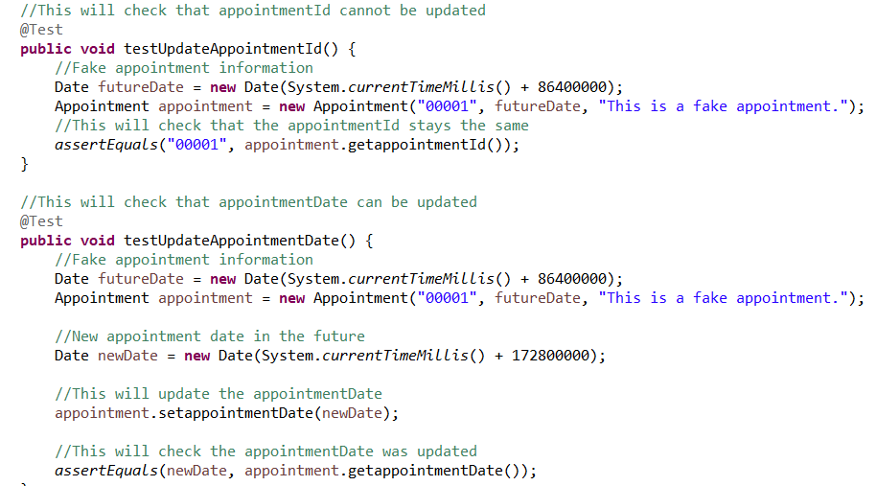
Avoiding biases meant strictly following the requirements that were outlined in the requirements of each milestone. I didn’t include extra requirements or tests outside of what the requirements needed. I also avoid using assumptions for my code and rather make sure that my code was free from errors and used the correct logic. If I had been biased, then I could’ve included extra logic that was not needed, and accidentally caused errors in my code, even if I didn’t intend them to occur. Being disciplined also meant that I had to keep my code for each milestone high quality and followed established testing practices for the most post. By being disciplined, I am able to keep my code error free, and I saved time from having to go back later in development to fix errors. If this was for a project at a real job, not having discipline could be extremely costly as myself or my team would have to go back later in development to fix mistakes, causing increasing costs to fix, less time to finalize other aspects of the project, and delaying the release of the software.

